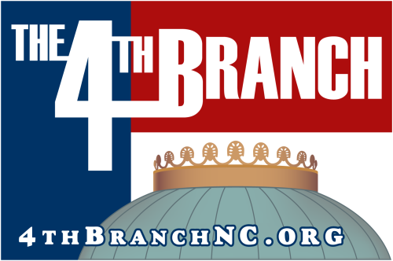

Date
The Honorable [First Name] [Last Name] – Use “The Honorable” if incumbent up for reelection.
[Office/Institution/Campaign, depending upon whether incumbent or outside candidate]
[Address Line 1]
[Address Line 2]
Dear [Title = Senator or Representative if incumbent] [Last Name],
I am writing to you as a member of an organization that is part of the 4th Branch. The 4th Branch is a coalition of government employee and retiree organizations committed to leveling the playing field in North Carolina for all government retirees through fair taxation. A large number of your voting constituents are represented in this Coalition. You can learn more about this organization at www.4thbranchnc.org.
Currently, military, federal, state, and local retirees in North Carolina who started their careers by August 1984 are exempt from paying state income tax on their retirement benefits. Those now retiring will have to pay tax on their hard-earned benefits. During the 2017-2018 session of the North Carolina General Assembly, legislation was filed that would have eliminated this inequity.
While neither of the two bills introduced during the session passed before it ended, The 4th Branch will continue its work to see this unfair, unwise tax policy eliminated. Not only will it benefit hundreds of thousands of North Carolinians, but the state’s economy will also benefit. For every $1 a veteran or retired public servant saves in state income tax, North Carolina accrues $2.50 in economic benefits. (Source: 4thbranchnc.org/resources)
If elected in November, The 4th Branch would like to know if you will introduce, sponsor, or vote in favor of legislation to eliminate the state income tax on the retirement benefits of ALL of North Carolina’s retired veterans and public servants during the 2019-2020 session of the N.C. General Assembly. Please let us know by contacting either Chuck Stone at otherchuckstone@aol.com or Robert Allen at retiredrobertallen@gmail.com . We look forward to hearing from you soon.
Sincerely yours,

